Central Lancashire Local Plan
Consultations Outcome Report

September 2020

Foreword – to be written for and agreed by members

Contents
1 Foreword – to be written for and agreed by members 1
1 Introduction 1
3 Issues and Options Consultation 2
4 Analysis of responses 5
5 Vision and Objectives 6
6 Delivering homes 8
7 Economic Growth, Employment, Education & Skills 17
8 Transport and How we Travel 28
9 Improving Health and Well-being 36
10 Climate Change & Resource Management 45
11 Locations for Future Development 56
12 Conclusions and next steps 66
Appendix 2 – List of Consultation Events and Venues 68
Appendix 3 – List of Sites Responses Received Against Specific Sites in Questions 64, 65 and 67. 68
Appendix 4 – List of Consultation Deposit Points 68
Appendix 5 – Detailed Response Analysis by Question 68

1 Introduction

  - The Central Lancashire Authorities of Chorley, Preston and South Ribble are working jointly on the Preparation of the Central Lancashire Local Plan (CLLP). The public consultation on the first stage, The Issues and Options Document, under Regulation 18 of the Town and Country Planning (Local Planning) (England) Regulations 2012, commenced on Monday 18th November 2019 and closed at 23:59 on Friday 14th February 2020 (12 weeks).
  - To encourage engagement from young people, a specific questionnaire was also prepared alongside the main Issues and Options Document targeted at 11 -21 year olds. This asked a series of questions on the future development of Central Lancashire, what the current issues are for this age group and what this age group would like to see happen to the area over the plan period. The findings of this are published in a separate report.
  - The new Local Plan will cover the period from 2021 to 2035 and will replace the Central Lancashire Core Strategy (2012), The Chorley Local Plan (2015), The Preston Local Plan (2015) and the South Ribble Local Plan (2015).
  - This report provides details of the consultation process undertaken, and identifies the key points made against the Issues set of for comment through the consultation document. It provides details of the organisations who responded and the level of responses received against the sites suggestions identified across Central Lancashire.

Issues and Options Consultation

  - The Issues and Options consultation document presented information on a number of topics which could affect how development takes place across Central Lancashire over the plan period. Topics discussed in the paper included housing; employment; education; retail and leisure; environment, health and travel. The consultation also presented information on sites which had been suggested to the councils as locations for development. The Issues and Options consultation document did not set out proposed policies, these will be developed from the responses received and presented in the next stage, the Preferred Options Consultation.
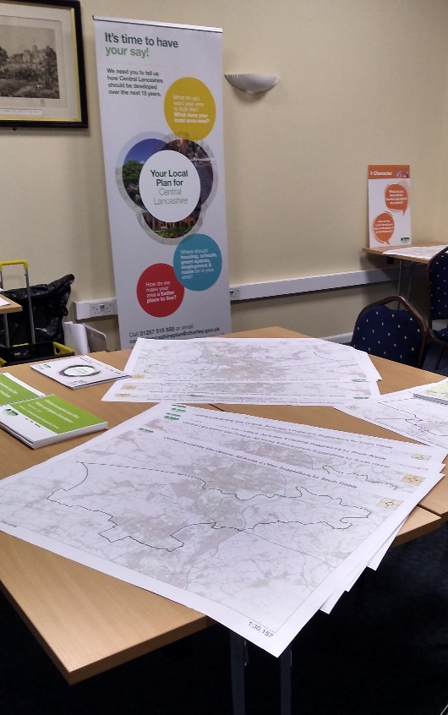
  - The Central Lancashire Local Plan Issues and options consultation ran from Monday the 18th November 2019 until Friday 14th February 2020. Consultation on the Central Lancashire Local Plan was undertaken in accordance with the adopted Statement of Community Involvement (SCI) for each of the three councils. The consultation was available online through Citizen Space, through which stakeholders could read the consultation documents and respond via an online questionnaire. The documents were also available on each of the councils’ websites and the Central Lancashire Local Plan Website, each of which provided details of how to respond. Social media was also used by the three councils to advertise the consultation and drop-in events which ran alongside it. In addition, press releases were also sent out and a number of articles ran in local papers including the Lancashire Evening Post and Chorley Guardian. Online adverts also ran on Blog Preston.
Consultation Event in Leyland
  - In addition to the online resources, paper copies were placed in all libraries across Central Lancashire and at other agreed locations, see Appendix 4 for a complete list. Stakeholders on the existing council Local Plan databases for the three councils were also notified of the consultation and 40 drop-in sessions also took place across the 12-week period, with over 900 people attending these events.

  - The drop-in sessions were held to enable people to speak to officers about the Local Plan and to answer any questions. The majority of events were well attended with a total of 912 people signing in. Those attending the events were also encouraged to sign up to our mailing list, and as a result of this consultation, an additional 1,235 stakeholders have signed up (725 from Citizen Space and 510 from drop-in events or by email request).

  - A full list of the locations and timing of each of the drop-in sessions can be seen in Appendix 2. In addition to these sessions, meetings were also held with Councillors to inform them of the Local Plan and to show them how to access the information and consultation online.

2.6 Social media presence was used to help highlight the meetings taking place and assisted in achieving the high volume of people attending the events. We also had an article and advert featured on Blog Preston, the first received 814 hits and the latter 107 redirections to the Local Plan website.

2.7 Parish Councils also helped in informing the areas they represent and in assisting in raising the profile of the Plan.

2.8 We did receive both positive and negative feedback regarding the use of Citizen Space and the online questionnaire, these are points which we will take on board for the next consultation.

Analysis of responses

  - The councils invited comments on the 68 questions contained within the Issues and Options report. Respondents could choose which section of the report/questions were most relevant to them and only answer those they felt were relevant to their concerns. As such not all questions have been answered by every respondent.
  - A total of 1,616 individuals and organisations responded to the consultation (1,200 though Citizen Space). Representations were received from the following groups:
- Individuals.
- Local Councillors.
- Parish Councillors.
- Statutory Consultees.
- Developers.
- Private landlords.
- Land agent.
- Community groups.
- Planning Consultants.
- Neighbouring Authorities.
  - A full list of those that responded can be found in Appendix 1. The majority of responses (1,468) were from individuals, with 148 from other parties. We also received a number of petitions against development, detailed below:
- 529 for sites at Pickerings Farm, Tardy Gate.
- 10 for sites 19S010, 19S011 and 19S01 in Hoghton.
- 6 for sites in Bretherton.
- 109 for sites 19C235x and 19C234x in Brindle.
  - The responses to the consultation are presented by chapter and question to aid comparison with the consultation document. The responses to each question have been analysed and key themes raised have been summarised.

Vision and Objectives

  - This section of the paper presented the draft vision for the Central Lancashire to be delivered by the end of the plan period (2036). This was also supported by a set of objectives with aim of delivering the overall vision of the plan. The questions in this section focused on whether Stakeholders felt this was appropriate and would deliver the changes those living, working and establishing businesses here want to see.

Question 1
  - Question 1 asked ‘Will the Vision and Objectives deliver the Central Lancashire you want to see?’. 637 responses were received, 152 (14%) answered said ‘Yes’ and 485 (76%) ‘No’.

Question 2
Question 2 asked ‘If not, what changes would you like to see?’.

  - The majority of respondents commented on policy areas generally, highlighting the key focus they would like the plan vision to take, or the key issues that mattered to them in their area that the objectives should seek to mitigate or target. The key points raised are set out below, with Appendix 5 providing a more detailed review of all the responses received.

- The need to protect Green Belt/green field, open or agricultural land from development.
- To address climate change and the environmental issues.
- Recognise role of Central Lancashire to the economic performance of the wider Lancashire region.
- Ensure land supply is sufficient to deliver the necessary homes and jobs, and ensure these are distributed fairly across the 3 authorities.
- Design areas to encourage move towards sustainable transport.
- Prioritise brownfield sites/ existing redundant buildings for future housing and employment sites.
- Require high quality design and build in all new developments and ensure it is in keeping with scale and character of the area.
- Place development in areas where infrastructure and services are sufficient to meet expected demand. Consider need for schools, doctors etc. when planning new sites.
- Protection of trees, hedgerows open space and local wildlife from development, provide new green/open spaces to establish green networks and deliver Biodiversity Net Gain.
- Encouragement for renewable energy investment.
- Promote energy efficient and carbon neutral homes, encouraging use of renewable energy and alternative heat sources in new developments.
- Ensure a variety of mixed housing tenures, including over 50s living, bungalows, starter homes, affordable homes and meeting local housing needs.
- Improve and implement accessibility criteria for the elderly and vulnerable in new home, public spaces and public transport design (dementia friendly, safe spaces).
- Provide more leisure facilities and green space such as sports clubs, youth centres, gyms, outdoor pitches, pools etc.
- Enhancement and investment into blue infrastructure (BI), including rivers, canals and their access, slipways, recognising the health and well-being benefits these spaces offer to residents.
- Provide more social and affordable housing.

Summary and Findings
  - In summary, the changes suggested by respondents for the vision and objectives were wide ranging and detailed. The suggested key focus for the vision was varied. This included protection of natural assets and prioritisation of climate change (especially by encouraging sustainable transport methods), a recognition of the need to grow the area’s economic ambition, a drive to deliver enough homes on viable sites through a sound plan whilst considering the needs of those already living in the area and the impact increased development will have on already stretched infrastructure and services. A more detailed summary of comments is presented in Appendix 5.
A582 in Lostock Hall

Delivering homes

  - This section of the Issues and Options contained 10 questions (questions 3 to 12 of the consultation) around the topic of how we deliver homes across Central Lancashire, looking at a series of questions around the amount and type needed, the locations we should be considering; as well as tackling topics around provision of student accommodation in Preston and meeting our duty in regards to provision of sites for gypsy and travelling communities. A summary of the of points made under each question is set out in this section, with more detailed analysis presented in Appendix 5.

Delivering Homes
  - Questions 3 to 6 of the Issues and Options focused on more general issues around the number of homes we need to plan for, and how new homes should be delivered across the three authorities.

Question 3
  - Question 3 of the consultation asked, ‘How can we make sure the homes we plan for meet the needs of everybody?’. A total of 606 responses were received to this question. The majority of responses were from individuals. The key themes arising from the responses received for this question are outlined below.
- The Local Plan should prioritise the use of brownfield land/ existing empty properties and avoid use of the Green Belt.
- Development in/around small villages should be kept to a minimum with homes specifically meeting the needs of the people living in those locations.
- Infrastructure needs to be in place to enable new development to take place, it should not be planned retrospectively.
- The plan needs to ensure the right mix of good quality sustainable homes and mix of tenures of homes that are needed are being planned for and meet the needs of those living in the area already.
- High quality well designed sustainable/green homes should be the priority with good public transport/cycling/walking links.
- Need more evidence on the use of the standard method numbers for housing requirements to reflect differing concerns of both residents and developers.
- Areas of flood risk should be avoided.

Question 4
  - Question 4 asked ‘How does the Local Plan ensure enough homes are provided so everyone has somewhere to live?’. A total of 435 responses were received to this question. Again, the majority of responses were from individuals. The key themes arisings from the responses received for this question are outlined below.
- Need to understand what the actual need is that we are planning for – standard method or higher to meet City Deal? And where that need should be met.
- Housing needs survey required to understand what the local requirements are to plan effectively.
- Make better use of empty homes/buildings/retail units etc. Avoid development in Green Belt/green areas.
- More large-scale developments like Buckshaw – consider redevelopment of Camelot site. Need to identify a variety of land to meet differing needs and ensure developer interest.
- More opportunities to be identified for self-build/cooperative style living.
- Focus around existing urban areas and build the right type of housing that is needed in that location.

Question 5
  - Question 5 sought views on the following question ‘Do you think the councils should plan for the minimum number of homes needed, but should aim to deliver more if we can?’. A total of 611 responses were received to this question, 292 people (48%) felt that we should only be planning for the minimum number, 94 people (15%) felt that plan for the minimum but aim to deliver more, whilst 225 people (37%) felt we should plan for less than the minimum. Those that suggested minimum or less came from those respondents who currently live within Central Lancashire, whilst the majority of those suggesting minimum but deliver more came from land owners, agents and/or developers with an interest in development options within the plan area.

Question 6
  - The last general issue discussed in this section is Question 6, this asked ‘Where do you think new homes should be provided in Central Lancashire?’. There were 646 responses received to this question. The key themes arising from the responses received for this question are outlined below.
- New development should be avoided in the Green Belt/ green areas and away from rural settlements.
- Need to ensure new housing is affordable and what is being built is actually what is needed for the area – not all 4/5 bedroom detached homes.
- Brownfield sites should be prioritised. Need a strategy for bringing back empty homes/buildings back in to use, with access to public transport key.
- Need to ensure green spaces planned into new developments.
- Need green homes which are planned away from areas at risk of flooding and designed to cope with future environment challenges.
- Developments should be close to the urban centres where public transport and infrastructure is sufficient and better access to employment.
- Need an even distribution across the plan area to ensure each area can meet their needs.
- The plan needs to identify a range of locations to meet the differing needs of the area.
- Distribution needs to align to planned infrastructure and growth ambitions (City Deal).
- Concentrate on existing safeguarded areas first and protect Green Belt/protected open land. Avoid ribbon developments which join towns together.
- A variety of site types and sizes needed to enable small/specialist builders into the market alongside large scale sites.

Summary and Findings
  - There are a number of similar themes identified through the responses to questions 3 to 6. There is a need to do further work in the evidence base to enable a better understanding of specific housing needs across Central Lancashire and how this can be used to inform the development options to be considered for housing delivery.

  - The need for priority of development focused on brownfield sites first and regenerate existing empty homes/buildings and bringing them back into use is something which many feel the plan should focus on, recognising the need for continued protection of the Green Belt.

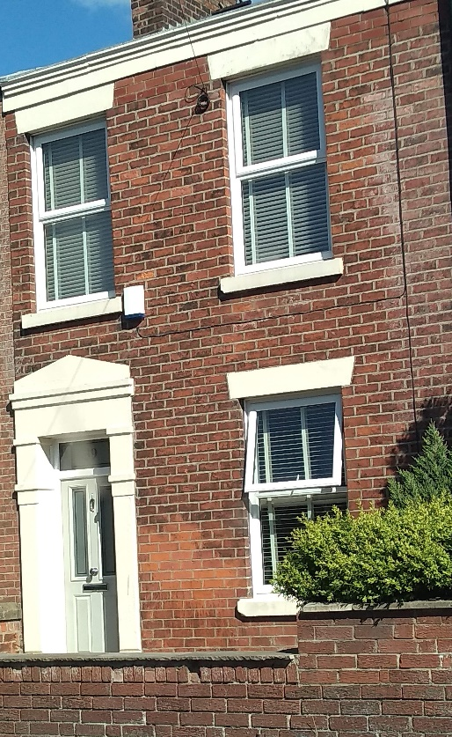
  - New development must be in sustainable locations to discourage a reliance on cars and must be energy efficient/carbon neutral to assist in reducing the impact on climate change.

  - There is concern that existing developments have had a negative impact on existing infrastructure. New sites must properly assess the infrastructure needs alongside those currently available and ensure this is delivered alongside the development itself.

  - The Local Plan also needs to consider what the appropriate housing figure is for the area and how existing growth ambitions of the City Deal and surrounding areas fits in with this.
Housing in Bamber Bridge

Student Accommodation
  - There were 3 questions specifically focusing on student accommodation provision within Preston, Questions 7 to 9 of the Issues and Options consultation. The summary of the findings is presented below.

Question 7
  - Question 7 asked ‘Do you think there should be no new purpose-built student accommodation in Preston?’. A total of 530 respondents chose to answer this question. 204 People (38%) agreed with this question, that Preston does not need any new purpose-built student accommodation, whilst 326 people (62%) did not agree.

Question 8
  - Question 8 asked ‘Do you think we should identify a student zone, centred around the University of Central Lancashire (UCLAN) campus, where new purpose-built student accommodation could be built and resist it elsewhere?’. A total of 528 people responded to this question, 418 people (79%) said yes there should be a student zone, whilst 110 people (21%) said no there should not.

Question 9
  - The final question on student accommodation is Question 9. This seeks to expand on peoples’ reasoning for their response to Question 8. Question 9 asks ‘Or do you think there is another way this can be dealt with?’ in relation to establishment or not of a student zone. A total of 254 responses were received to this question, as summary of the key themes presented below.
- The majority of respondents felt there was enough accommodation already.
- The Local Plan needs to look at regenerating areas of the town centre near the university itself.
- The majority of responses felt accommodation should be provided close to the university, with both high and low rise options considered. A student village should be considered.
- Outlying areas well connected by public transport should be also considered, to reduce areas becoming empty when university is out for summer.
- A lot of recognition of the value UCLAN brings to the area and a need to capitalise on this to improve Preston City Centre.

Summary and Findings
  - There were a range of ideas expressed around the issue of student accommodation that sought to ensure the integration of students and their living into the city and recognising their value, while at the same looking to limit the provision. Other views included ensuring accommodation options were adaptable to other uses and not restricted to UCLAN alone, but other educational establishments. Zoning was supported, as was a need to ensure housing was centred near existing services and transport for students.

Gypsies and Travellers
  - There were 3 questions specifically focusing on meeting the needs of Gypsy and Traveller and Travelling Showpeople within Central Lancashire, Questions 10 to 12 of the Issues and Options consultation. Below provides a summary of the key themes raised, with Appendix 5 providing a more detailed breakdown of the responses received.

  - A Gypsy and Traveller and Travelling Showperson Accommodation Assessment (GTAA) was undertaken by consultants ARC4 on behalf of the Central Lancashire in July 2019.

  - The GTAA identified the current need for provision across Central Lancashire and concluded that the majority of provision can be catered for by the progression of existing sites. It also identified a need for a replacement site for the unauthorised site at Rosemary Lane, Preston. If this site were to be authorised, a replacement site elsewhere in Preston would be able to be much smaller.

  - To help deliver this need, the Issues and Options consultation asked a number of questions around how we should be planning to meet this provision.

Question 10
  - Question 10 of the consultation asked ‘Should the existing unauthorised Gypsy and Traveller site at Rosemary Lane in Preston be authorised for use by Gypsies and Travellers, or should a larger site be found somewhere else?’.

  - A total of 254 responses were received for this question, the majority of which were from individuals. The key themes arisings from the responses received for this question are outlined below.
- Recognition that a site is needed but not all those who responded felt this was the correct location.
- The decision to authorise the site should be made through the planning application process.
  - Those who responded identified the factors which need to be taken into consideration in relation to this particular site and in finding alternative sites, including a site for a transit facility (specific site suggestions for a larger site are referred to at question 11). These included:
- Is the site in a suitable and accessible location, with appropriate land, access and infrastructure?
- The travelling community would need to be aware it is available to use.
- The site would need to be effectively managed/supervised by the Council.
- Concerns about access and facilities were raised by the Planning Inspector when the site was granted temporary consent, and these need to be addressed.
  - Other general comments included:
- Need to follow government guidance.
- Ensure infrastructure is in place to ensure effective management of the site and its acceptance in the local area.
- They are a group who have been routinely discriminated against, and this community should be protected, respected, and treated with dignity. They should have access to safe, clean dedicated sites.
  - Some comments received were more relevant to transit site provision and are therefore covered in that section, at question 12.

Question 11
Question 11 asked ‘If a larger site should be found, where do you think it should be?’. A total of 126 responses gave an opinion on this question. The majority of responses were from individuals. General comments received to this question have been incorporated into question 10 above. Specific site suggestions from question 11 are set out below.
- A number of sites were suggested on known brownfield land across central Lancashire and near to existing major roads. Sites need to be in a suitable sustainable location, and with access to amenities and infrastructure.
- Travellers should be consulted, and sites should be identified after analysis of the evidence.
  - The GTTA also identified a need for a transit site for communities travelling through the area. Such a site allows for users to stay for up to 3 months.

Question 12
  - Question 12 asked ‘Where could a transit site be located?’. A total of 126 responses gave an opinion on this question. The majority of responses were from individuals. The key themes arising from the responses received for this question are outlined below.

  - Many responses tended to equate and combine the proposed location for a larger gypsy or traveller site with the need for a traveller transit site.

  - Some felt no provision should be made for these communities unless the costs could be charged to the communities utilising it or employers using traveller labour could provide pitches on their land for the season.

  - Many felt the decision should lie with the communities themselves, with a site chosen that is most suited to their needs.

  - A number of locations were put forward, with a general approach to be for sites to be self-contained and well managed to minimise impact on the local area. Sites suggested were considered as well as accessible sites in proximity to major roads and motorway junctions or services.

Summary and Findings
  - There were a number of similar themes identified through analysis of the responses to questions 10 to 12. Concerns were raised about environmental impacts, local amenity, and the management of sites, but there was no overall consensus on normalising the Rosemary Lane site or finding a larger site elsewhere. However, there were many useful comments about the type of site and infrastructure required, the importance of accessibility (for transit sites) and suggestions for potential locations, including brownfield sites.

  - The GTAA 2019 established the need for Gypsy and Traveller provision in the area, in line with Government requirements. Further work will be carried out as part of the Local Plan process, underpinned by the evidence base, to ensure the most appropriate sites are brought forward to meet the needs (permanent pitches and transit sites) of Gypsies and Travellers in Central Lancashire, whilst minimising any potential impacts on the environment and local amenity.

Economic Growth, Employment, Education & Skills

  - This section of the consultation included 15 questions looking at issues around economic growth and employment land provision, education and skills, the role of town centres and policies to protect them, and leisure and cultural needs of the area. The key themes under each question are captured below, with a more detailed summary presented in Appendix 5.

  - Questions 13-15 focused on the types, location and distribution of growth/jobs in the area.

Question 13
  - Question 13 asked ‘Are there any other types of economic growth the plan should be planning for?’. A total of 261 responses expressed an opinion to this question. The key themes which came from Question 13 are summarised below:
- Positively and proactively encourage sustainable economic growth.
- Identify new employment sites to address shortfalls of provision for all B-use classes. Need to link key economic assets and opportunities in Central Lancashire to other areas of Lancashire and beyond.
- Promote and support the green economy / green energy sector.
- Support the rural economy, including local agriculture / horticulture and local food produce / products.
- The employment distribution across Central Lancashire should be aligned with the distribution of new housing to maximise the potential for active travel and use of public transport
- Adequate communication infrastructure to support digital business, home working etc.
- Ensure town centres / the high street is healthy.

Question 14
  - Question 14 of the consultation asked ‘Where should the distribution and priority locations for economic growth be in Central Lancashire?’. A total of 276 responses expressed an opinion to this question. The key themes are summarised below:
- Focus should be on brownfield sites and occupying vacant units, and the expansion of existing economic centres/industrial estates/business parks.
- New sites should be in accessible, sustainable and deliverable locations.
- Recognise and address the specific locational requirements of different economic sectors.
- Employment and education sites of a specified size should have travel plans.
- A flexible approach which is reactive to change/market signals. Policies should not be too restrictive.
- Distribution should be more widespread/even. Different areas could offer different types of alternative uses so not in direct competition.
- Rural areas if in sustainable locations / diversification of agriculture etc. Support rural business, including sustainable rural tourism and leisure.

Question 15
  - Question 15 of the consultation asked ‘What kind of jobs would you like to see created in Central Lancashire’. A total of 295 responses expressed an opinion to this question, the key themes arising are set out below:
- A diverse and inclusive range of jobs/sectors including for all skill levels
- Reduce reliance on the large local employers.
- Build on strength of UCLAN and BAE Systems, key public sector (government / health etc.) who are key local employers, and jobs complimentary to those in adjacent cities like Manchester and Liverpool as part of a larger Northern Hub.
- Refer to the findings of the Employment Land Study (ELS).

Summary and Findings
  - Analysis of the responses to questions 13-15 showed strong support for positively and pro-actively encouraging sustainable economic growth and meeting local needs. The amount and distribution of development should be informed by the ELS, and there was recognition of the benefits of utilising brownfield land, and accessible sites. There was support for building on the strengths of existing local business and industry and upskilling. Specific types/sectors of growth referred to included high skilled jobs, the digital sector, and the green economy, amongst others.

  - Questions 16-17 focused on school provision, apprenticeships and graduates.

Question 16
  - Question 16 of the consultation asked ‘Do you have any views about school provision in Central Lancashire?’. A total of 348 responses expressed an opinion to this question.
- Existing school provision and choice is insufficient and full to capacity.
- There are insufficient safe, sustainable and affordable travel options (school buses too expensive, etc).
- School provision should be supported through CIL/S106 monies and contributions should be spent within a close radius of the development approved.
- School provision should be more pro-active rather than re-active.
- Improve provision for Special Educational Needs and Disabilities (SEND) pupils.
- More higher education needed dedicated to vocational courses that reflect the needs of businesses.

Question 17
  - Question 17 of the consultation asked ‘How can the plan help deliver enough job opportunities for apprenticeships and graduates?’. A total of 254 responses expressed an opinion to this question. The key themes provided are summarised below:
- Planning policy should require local labour for new development, including financial incentives and support.
- Build on the strengths of existing business by working in partnership with employers and Higher Education establishments and universities e.g. UCLAN & Edge Hill.
- Boost the economy and attract large sustainable business.

Summary and Findings
  - Analysis of the responses to questions 16-17 identified that the capacity of schools is a big concern, particularly the capacity to meet local needs, and/or allow greater choice. To encourage more apprenticeships and job opportunities for graduates, it was suggested that there should be closer partnership working with employers and Higher Education establishments to align skills and education with local job opportunities. It was also suggested that planning policy should require local labour for new development, and that employers should be required or incentivised to take on local graduates and apprenticeships. These issues will be considered through the Local Plan process, working closely with education providers / Lancashire County Council.

  - Questions 18-24 focused on how to make our town and district centres better, revisions to boundaries, types of uses, and thresholds.

Question 18
  - Question 18 of the consultation asked ‘How do you think we can make our town centres better?’. A total of 374 responses expressed an opinion to this question.
- Town centres need investment. They should have a unique identity to increase footfall, adapt to the rise of online shopping, and be flexible to react rapidly to future change.
- Ensure vitality and viability outside office hours and promote the evening/night-time economy. However, there should be restrictions on the number of fast food outlets/takeaways.
- Make them a more attractive and enjoyable.
- Have less peripheral centres and restrict out of town shopping complexes / retail parks / supermarkets.
- Improve accessibly by sustainable means such as public transport and walking/cycling routes.
- Help upstarts/small local independent businesses and shops with reduced rent/business rates/tax reliefs, and the availability of business advisers.

Question 19
  - Question 19 asked ‘Do you have any comments to make on the proposed revisions to town centre boundaries in Annex 6?’. Annex 6 includes local centres as well as town centres. There were 170 responses who expressed an opinion. There was general support for the proposals.
Preston
- Support for the contraction of Preston/decommissioning Church St from the Primary shopping area. There is a need to regenerate Church Street. The reduction in Preston city centre is welcomed, but it could be taken further – for example removing the part of Friargate between Ringway and UCLAN, and the Market cinema development. Queens Retail Park should also be reconsidered. The area facing the bus station (Tithebarn Street) should be included.
- The area of Fulwood along Garstang Road / Lytham Road needs more of a retail element.
- Cottam Village Centre (Cottam Brickworks) / North West Preston needs adding.
Chorley
- The Chorley Whittle-le-Woods local centre should not be deallocated.
- Lancaster Lane proposal, further expansion will be difficult in this area without changes to the junction.
- Do not remove the Asda store from Chorley Town Centre Boundary.
South Ribble
- Extend the Walton-le-Dale local centre to include the petrol station on Victoria Road, the White Bull pub at the end of Cuerdale Lane, and the shops at the end of Chorley Road opposite.
- Proposed retail boundaries in Longton would be unnecessary.

Question 20
  - Question 20 asked ‘Do you have any comments to make on the proposed retail hierarchy?’ There were 164 responses who expressed an opinion on this. Most of the comments were generally supportive.
- Support Preston as the principal centre in Central Lancashire.
- Bamber Bridge should be Tier 2, not 3.
- Leyland should be Tier 3 not 2, and/or needs investment.
- Clayton Green should be Tier 4 not 3.
- Many village centres are not mentioned in this report but are important locally.
- There is a need to restrict the growth of out of town retail centres and consider their impact on the hierarchy.
- The hierarchy is too simplified an approach as it just considers retail establishments - other facilities and accessibility should be considered.

Question 21
  - Question 21 refers to the opportunity for the site surrounding the railway station in Preston, potentially as a commercial quarter. Question 21 asked ‘What kind of uses would you like to come forward in this area of the city centre?’. There were 160 responses who expressed an opinion on this. Many expressed support for a commercial quarter, and support anything that makes this area more attractive to businesses and individuals. Various potential uses were suggested.
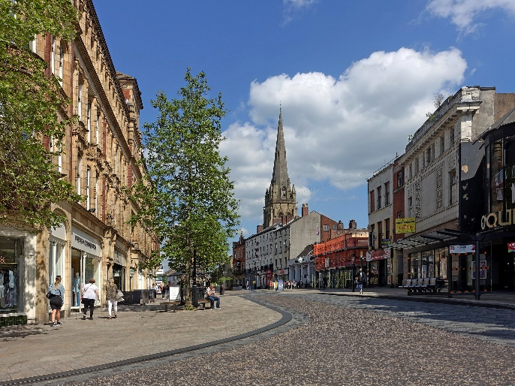
- Mixed use residential with retail and leisure opportunities.
- Transport hub, including linking the train station to the bus
- Community space, tourism, culture/arts & crafts, music, events/festivals/markets, recreation, small local independent retailers and green open space.
Preston City Centre Regeneration
- Sport/leisure/recreation, gym/swimming pool, theatre/cinema, night-time economy.
- Youth zone, family friendly areas, play areas.

Question 22
  - Question 22 of the consultation asked ‘Do you agree that these distance thresholds will protect our town centres?’. A total of 179 responses expressed an opinion to this question.

  - The split was 121 for ‘Yes’ (68% of the responses to this question) and 58 for ‘No’ (32%). The majority of people therefore were in support of these thresholds.

Question 23
  - Question 23 of the consultation asked ‘If not, how should the thresholds be amended?’. A total of 89 responses expressed an opinion to this question.
- Restrict retail parks.
- All the thresholds are too small - this would be counterproductive to attracting jobs and business.
- The National Planning Policy Framework (NPPF) states that any impact assessment should be appropriate in scale to what is proposed. The test should be amended by reference to ‘appropriate assessment’.
- The issue is less about specific thresholds and more about accessibility/public transport/infrastructure, the type of retail use, and the quality.

Question 24
  - Question 24 of the consultation asked ‘Are there any improvements required for specific centres?’. Of the 299 responses to the first part of this question, the split for specific centres identified as needing improvement was:
- 100 respondents (33.5%) identified Preston as needing improvement.
- 85 (28.5%) identified Chorley.
- 62 (20.7%) identified Leyland.
- 52 (17.3%) identified any other district/local centre.

  - There were 214 responses who went on to give general comments about specific improvements needed, including:
- Reduce business which attract anti-social behaviour such as gambling outlets and fast food chains.
- Improve the overall appearance of the town centres and empty units and include more green spaces.
- Encourage Small and Medium Enterprises (SMEs)/local business/independents into the area.
- Need a flexible approach rather than restrictive approach to town centres to retain the vibrancy of centres.

Summary and Findings
  - Analysis of questions 18-24 revealed that town centres need investment, and should move away from being predominantly retail-led, to include a diverse range of uses including residential, leisure and culture, and to make them an attractive/niche ‘destination’, with local independent offerings and improvements to the public realm, for example. Town centres should also be more accessible by all modes of travel and be flexible and adaptable to change.

  - Preston was supported as the principal centre, but it was also identified as being the centre in most need of improvement. Reducing the size of the primary shopping area in Preston was generally supported to make the centre more compact, and there were various uses suggested for the area near the train station, including commerce and cultural offerings amongst other things.

  - There was also general support for the proposed distance thresholds to protect town centres. However, questions were raised about the impacts of out of town retail parks not being fully addressed. The Local Plan process will consider all available evidence including retail studies when formulating relevant policies in the new Local Plan.

  - Questions 25-27 referred to what defines the area as a place, and what leisure and cultural opportunities are needed.

Question 25
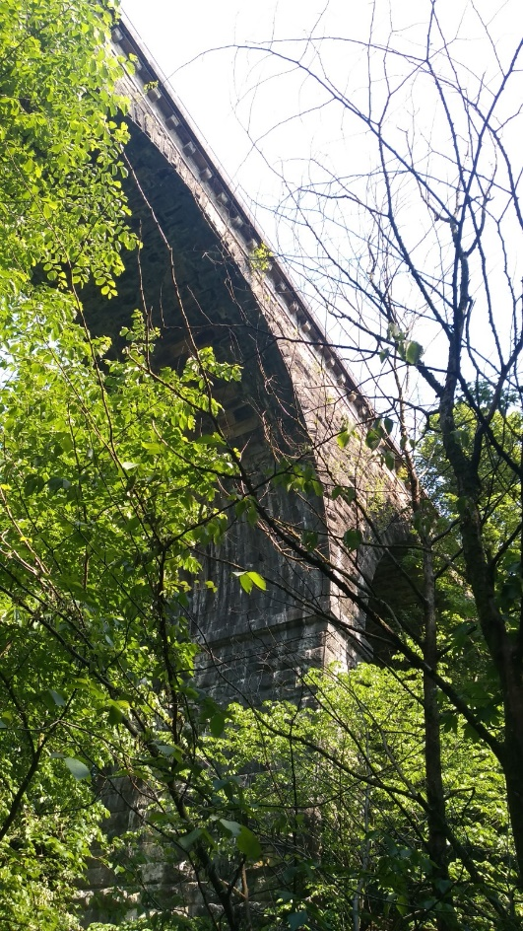
  - Question 25 of the consultation asked two questions. Firstly, ‘What do you feel defines Central Lancashire as a place?’. There were a total of 252 responses to this question.
- Its diversity: a mix of urban/rural/semi-rural; distinct towns and villages and communities.
- Heritage: Strong industrial and cultural heritage/historic buildings/architecture.
- Local business, produce and the markets. A Fairtrade city/area. Arts and crafts, unique goods.
- Sport and leisure.
- Preston: Heritage and culture. Preston Guild. University city (UCLAN). Commercial centre of Lancashire. Preston North End (PNE) FC.
Railway Viaduct at Hoghton Bottoms
- Chorley: Market town. Chorley FC.
  - The second part of Question 25 asked: ‘What is special and unique about Preston city centre and the towns within Central Lancashire that we can focus on to be the blueprint for future generations?’. There were 223 responses to this question.
- History/industrial & cultural heritage, good design and retention of character of buildings and areas.
- The markets, local goods/produce, and support for SMEs, local independent businesses. The high street, café culture, micro-breweries, etc.
- Employment and enterprise hubs. UCLAN/Education.
- Tourism, recreation/leisure and sport (including PNE FC/Chorley FC).
- The Arts, events. A unique offering that makes it different to other towns and cities and a destination in its own right.
- Preston – Culture, university city, heritage( Winkley Sq./Harris Museum and Library), and the River Ribble & parks.
- Chorley – Market town. Leisure, local events.

Question 26
  - Question 26 of the consultation asked ‘How important do you feel leisure and cultural opportunities are in helping to improve Preston city centre and the towns within Central Lancashire?’.

  - The majority felt that leisure and cultural opportunities were important. Out of the 391 responses who expressed an opinion about the importance of leisure opportunities;
- 276 (70.6%) said that leisure was very important.
- 84 (21.5%) said it was somewhat important.
- 18 (4.6%) said it was neither important nor unimportant.
- 2 (0.5%) said it was somewhat unimportant.
- 11 (2.8%) said it was very unimportant.

  - Out of the 383 responses who expressed an opinion about the importance of cultural opportunities;
- 236 (61.5%) said that culture was very important.
- 95 (24.8%) said it was somewhat important.
- 34 (8.9%) said it was neither important nor unimportant.
- 6 (1.6%) said it was somewhat unimportant.
- 12 (3.2%) said it was very unimportant.

Question 27
  - Question 27 of the consultation asked ‘What cultural and leisure opportunities do you feel are missing in Central Lancashire?’. A total of 255 responses expressed an opinion to this question.
- All opportunities should be affordable and accessible to all. Need to encourage different cultures to mix and ensure the changing needs of the population are met.
- Improve the public realm. Public art/sculptures/floral displays. Make more use of historic / heritage assets, heritage walks, local history and traditions, have ‘Quarters’ (like in Manchester).
- Entertainment venues - more quality/large venues and events – e.g. theatre, live music, concert, creative, arts & crafts & literature venues. More conference, events and exhibition centres (e.g. in Preston).
- More sport and leisure facilities (indoor and outdoor), and make better use of existing parks, green spaces, and waterways
- Become more of a ‘destination’. Create a niche to have a different offer than Manchester and Liverpool.
- More community focused spaces, buildings and services.

Summary and Findings
  - Analysis of questions 25-27 showed that Central Lancashire means many things to many different people. However, common themes identified included the area’s strong industrial and cultural heritage, the strength of local industry and its skilled workforce, the markets, and the diversity of landscape, including strong individual communities with individual character, interspersed with attractive green open space. It was also noted as being in a great location, close to other major cities and holiday/recreation destinations.

  - The vast majority felt that leisure and culture were very important to them. In particular a diverse range of uses in town centres, including the evening and weekend economy, and which are accessible to all. To help make centres become more of a niche destination, suggestions included more entertainment venues, tourist attractions, and sport, leisure and recreation opportunities. It is clear that the vast majority of people consider leisure and cultural opportunities to be important factors for improving town and city centres. The Local Plan will seek to ensure there is a diverse mix of uses in town centres, and that they remain vibrant at all times.

Transport and How we Travel

  - This chapter of the Issues and Options document included 11 questions covering active travel, reducing the number of vehicles on the roads, public transport and infrastructure. The questions are looking at how people currently travel, what needs to happen to encourage people to use their cars less and what infrastructure improvements are needed to achieve this. A summary of the key themes identified are set out below, with a more detailed analysis presented in Appendix 5.

  - Questions 28-30 looked specifically at making travelling better and safer, encouraging people to walk and cycle more and reduce car use.

Question 28
  - Question 28 of the consultation asked ‘How can we make travelling around Central Lancashire better and safer’. A total of 446 responses were received to this question, and the key themes are outlined below.
- The Local Plan should reduce the need to travel and ensure new development is located in sustainable accessible locations.
- Policies should promote active travel (cycling and walking and consider identifying more pedestrianised areas).
- Provide cheaper and more reliable public transport which connects areas better, with more park and ride options. It should also consider requiring all public transport to be green/clean.
- Investment in the road and rail infrastructure, including highway safety and maintenance, improving traffic flow and reducing congestion (particularly in Preston), better traffic control (such as speed restrictions, traffic calming, regulation & enforcement, clearer signage, reducing HGV access etc.).

Question 29
  - Question 29 of the consultation asked ‘How can the Local Plan encourage people to walk or cycle more?’. A total of 442 responses were received to this question, and the key themes are outlined below.
- Directing growth to the most accessible locations, close to amenities, housing, employment, schools and local centres, etc.
- Incentives to make active travel the mode of choice for shorter journeys, with all new development designed to reduce reliance on cars. All new development should also link to existing footpaths and cycleways, and Travel Plans should be required through planning policies that encourage active travel specifically.
- Require space to be provided for cycle infrastructure such as storage and changing/showering/locker facilities in all new developments.
- There is a need for more dedicated cycling routes, segregated from vehicular traffic, and safer road crossing points. Routes should be continuous, connected, cleaner, more attractive, well-lit, well surfaced & well maintained.
- More pedestrianisation of town centres, making them more accessible to all, including the mobility impaired. Also making the public realm more attractive.

Question 30
  - Question 30 of the consultation asked ‘How can the Local Plan reduce the number of cars on the roads?’. A total of 439 responses were received to this question, and the key themes are outlined below.
- Give people an incentive/viable alternative to change the way they travel. Transition towards a movement hierarchy that priorities sustainable modes of transport such as cycling, walking and public transport for shorter journeys, whilst also providing for the transport needs of those who are physically inactive due to disability or illness.
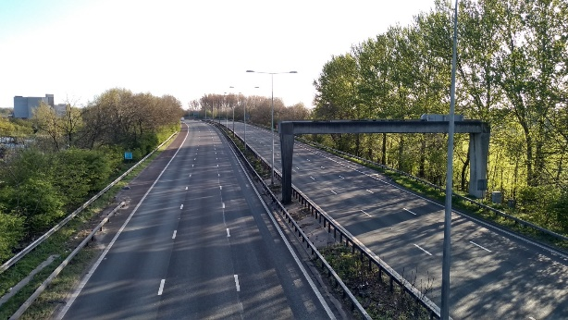
- Improve public transport - with sufficient capacity, including more park and rides.
- New development needs to be in sustainable and accessible locations close to amenities and facilities and transport hubs.
- Reduce congestion and improve traffic flow.
The M6 Motorway
- Encourage working from home, car sharing, communal car parks, travel plans, etc.

Summary and Findings
  - Analysis of questions 28-30 revealed various suggestions for making travelling easier and promoting active travel. These included reducing the need to travel, through ensuring new development is prioritised in accessible and sustainable locations, as well as investment in active travel infrastructure such as safe pedestrian and cycle routes and provision of space for cycling facilities in new developments.

  - Investment is needed in a better performing public transport system, ensuring this is accessible to all and is an affordable, viable alternative to the car. The Local Plan, underpinned by the evidence base and working closely with key partners including the highway authority, can help deliver this infrastructure through appropriate planning policies and developer contributions.

  - Questions 31-33 focused specifically on car parking provision.

Question 31
  - Question 31 asked: ‘Do you think there is too much car parking in Preston city centre, not enough or about the right amount?’
  - 427 people chose to respond to this question. Options to answer and their respective responses included ‘too much’ (2.5%), ‘about the right amount’ (63.4%), ‘not enough’ (26.%) or ‘N/A’.

  - Most responses addressed concerns, ideas or opinions around the type, levels or state of provision of parking in the centre.

  - Ideas given around the availability of parking included feelings that current capacity should be reduced to disincentivise car use.

  - Suggestions noted a need for more short-stay capacity or family designated bays. Greater disabled parking was supported with the note that access centrally to shops and services was important for these and other vulnerable groups.

  - There was general agreement that capacity should be improved during peak times (rush hours or Saturdays) or seasonal peaks (Christmas) and that an evening provision should be made available to improve footfall to the night-time economy in the centre.

  - The quality of parking was a key theme. Spaces being too tight and car parks being poorly lit, uncovered by CCTV and unguarded were concerns, while the overall quality was felt to be poor.
  - Alternative transport methods to cars were a key theme, with many stating that people should be encouraged to use buses, trains, park and ride or cycling as alternatives, and that public transport should be free across the city.
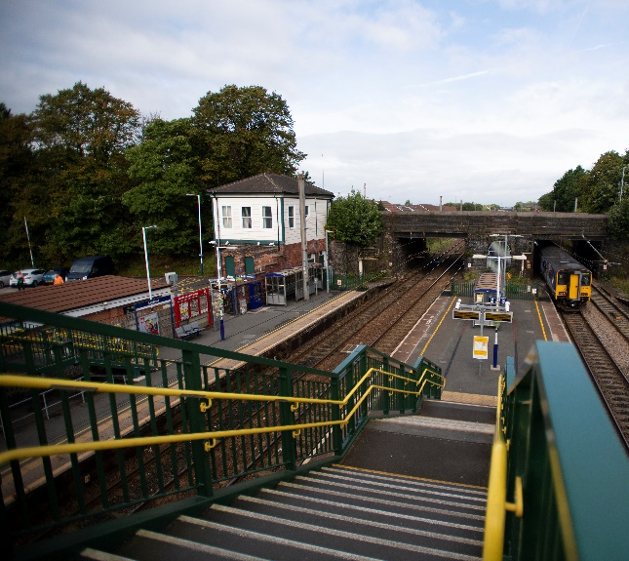
  - ‘Park & Ride’ facilities services were thought to be already good, but more should be made available.
  - It was highlighted that more electric vehicles (EVs) were expected to replace conventionally fuelled cars, so more spaces should be provided with electric charging points.
West Coast Mainline at Leyland Station
  - Some responses highlighted the function of parking as an economic driver, integral to the economic health of the cities retail and service-based business and is an essential component of competitiveness versus out-of-town outlets like Deepdale Retail Park/The Capitol Centre, or rival cities Manchester/Liverpool.

Question 32
  - Question 32 asked: ‘Would you support a policy which seeks to manage, and over time, reduce the amount of car parking available in town and city centres in Central Lancashire?’. 436 people responded to this question, with 147 answering ‘Yes’ (34.9%) and 274 (65.1%) answering ‘No’.

Question 33
  - Question 33 asked: ‘Do you think the car parks available in Central Lancashire are fit for purpose and in the right locations?’. 360 people responses to this question, with 220 (61.1%) answering ‘Yes’ and 140 (38.9%) answering ‘No’.

Summary and Findings
  - Analysis of questions 31-33 showed that people felt there was about the right amount of car parking provision within the city and town centres in Central Lancashire. A number of respondents suggested that more parking was needed, not less, with a need for more park and ride facilities and parking for those with accessibility needs. However, there were responses noting the need to promote alternative modes of transport into the town centre as viable alternatives to the car. Issues were also raised around the quality and affordability of car parks. The Local Plan will need to ensure that the issue of car parking is fully considered as the plan progresses, working closely alongside the Local Highways Authority and other key stakeholders.

Question 34
  - Questions 34-38 focused on what needs improving most in the area, and how public transport, electric vehicles, cycling facilities, and where additional park and ride facilities are needed.
  - Question 34 of the consultation asked ‘How can we improve public transport and encourage more people to use it?’.
  - A total of 313 responses were given. The key themes identified are summarised below.
- Reconsider the approach to town centre parking and restricting car access into town centres.
- Better, more reliable and wider reaching public transport network, especially for those in more rural areas which are currently underserved. And ensure new developments are served by public transport.
- More park and rides e.g. at Junction 31 of the M6 and parking at key transport hubs.
- Green transport fleet / electric vehicles / smaller buses
- Alternative options such as trams / cable cars, call-on-demand buses, request stops.
- Secure developer contributions for public transport infrastructure.

Question 35
  - Question 35 of the consultation asked ‘What do you think needs improving most in Central Lancashire?’ (with regards to public transport in Question 34). 481 people responded to this question or 29.8% of the total respondents. There were 4 options given, and each option was ranked in order of importance. The options in order of importance were Public transport, cycle and walking routes, the existing road network and lastly, park and ride services. The chart shows public transport clearly of the upmost importance, while the importance of the road network was split for those ranking it highest as well as lowest. Cycling and walking had the second most support, though perceived importance of this was much more spread, while park and ride was near-tied for least importance and least important.

Question 36
  - Question 36 of the consultation asked ‘What needs to be in place to encourage the move towards electric vehicles?’. A total of 414 responses were received to this question.
- The Local Plan needs to support the move towards electric vehicles, ensuring provision of electric charging points (including rapid charging), in various accessible locations, including in all car parks and in new housing developments were possible. Community charging points will also be required where properties have no driveway/off road parking e.g. terraced houses/apartments etc. Consider use of street furniture for charging points.
- Incentives – e.g. better technology and affordability such as local grants for purchasing cars and incentives for self-generating renewable energy for households to charge cars, subsidies/zero tax.
- Highway led incentives, including priority lanes to reduce journey times and priority/reserved and free/cheaper parking for electric vehicles.

Question 37
  - Question 37 of the consultation asked ‘In addition to cycleways, what cycle facilities does Central Lancashire need, and where should these be located?’. A total of 282 responses were received to this question.
- Secure, well-lit, covered cycle storage, lockers, and shower & changing facilities, at all frequently visited destinations (including transport hubs, and on public transport itself e.g. trains/buses), places of employment, public buildings, town centres/shops, employment, education, community/health and leisure facilities, etc.. Promote ‘Park and cycle’ schemes instead of/alongside park and rides.
- Facilities en-route, e.g. rest points/WC facilities, parking areas, cafes and cycle shops/repair service centres, e-bike charging points and other facilities, particularly along the main commuting/well used routes.
- More purpose-built cycling facilities for sport/leisure/recreation – e.g. velodrome, mountain bike track, enclosed cycle track for community use.

Question 38
  - Question 38 of the consultation asked ‘Where is there a need for more park and ride facilities?’. A total of 264 responses were received to this question, and the specific sites referred to are outlined below. Various locations were suggested, whilst some also suggested there was no need for any.
- To serve all large new housing developments, large employment areas, education establishments (e.g. UCLAN) and hospitals (e.g. Royal Preston and Chorley hospitals).
- Should serve all town centres, from all sides/suburbs/popular routes in. Park and rides need to be further away from the town centres to avoid congestion en-route to the park and ride.
- Should be on brownfield sites, and on new major roads (e.g. the new Preston Western Distributor).
- At transport hubs/intersections, along the main bus routes and train stations and at key motorway junctions. A number of specific routes suggested which need to be looked at.
- Increase parking capacity (and options – e.g. buses and trains) at existing park and ride sites e.g. Chorley, Buckshaw village, Portway, Leyland. There should also be ‘car sharing’ car parks, and additional smaller car parks on established routes.

Summary and Findings
  - Analysis of questions 34-38 suggested that people will need incentives to use public transport more regularly. It was suggested that a fully integrated and affordable, reliable public transport system is required with increased frequency to make this a viable alternative to the car. It needs to be more accessible, with better links, more parking at transport hubs, and a green fleet.

  - It was questioned whether electric vehicles should be encouraged at all, but to encourage more people to use them it was clear that infrastructure needs to be in place first, such as charging points, and priority lanes/emissions zones.

  - To encourage active travel the message was similar in that the infrastructure needs to be in place (such as cycle storage and changing facilities at key destinations / employment, and improved availability of cycle hire). Suggested locations for park and rides were at transport hubs and other locations to serve town centres, employments areas, universities and hospitals. However, it was suggested that routes should start further away from town centres, with rapid shuttle services. Working closely with the highways authority and other key stakeholders, the Local Plan process will seek to improve sustainable travel options for all.

Improving Health and Well-being

  - This section of the report contained 12 questions on a number of topics around health and well-being. The questions covered issues around obesity, active design of areas and providing healthy neighbourhoods. It also sought views on provision of community facilities, employment and income and living conditions, and the effect of these issues on health and well-being. A summary of the key themes is presented in this section, with detailed responses presented in Appendix 5.

Question 39
  - Question 39 asked ‘How can planning improve health and reduce health inequalities?’. A total of 337 responses were received which raised the following key themes.
- Protect and improve the full range of social and healthcare provision including Chorley hospital A&E.
- Protect and provide more green space for improved air quality, health and well-being and general recreation benefit
- Improve community facilities and build development which build on the idea of establishing communities and provide amenities close by.
- Improve the quality of developments including those in the affordable bracket and locate them near to employment opportunities.

Summary and Findings
  - There are a number of factors identified as impacting health and resulting in the inequalities seen across central Lancashire. The way areas are designed and the provision of amenities and green space in particular are highlighted as factors which need to be addressed. Employment is also key, and the local Plan should seek to ensure increased opportunities for employment for all.
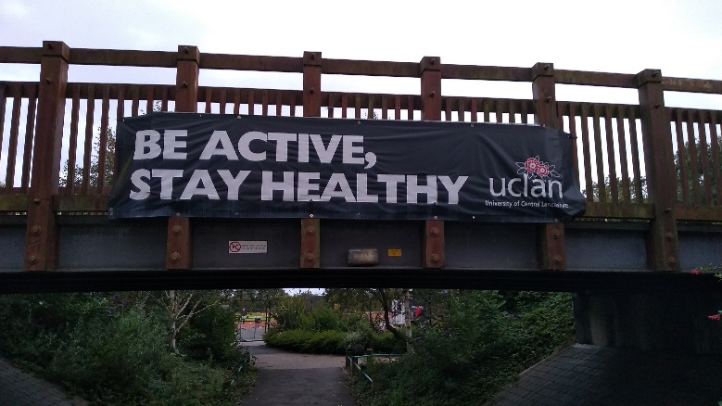
UCLan Sports Arena

Question 40
  - Question 40 asked: ‘Do you support the principle of a policy that seeks to restrict new hot food takeaways?’. A total of 425 responses were received. Of these 320 supported the principle which amounts to 75% of respondents. Therefore the principle of restricting hot food takeaways in the new Local Plan was supported.

Question 41
  - Question 41 was a supplementary question to this and asked ‘If you do, what would you suggest a policy contains?’. 241 responses were made. The main issues raised were:
- Require policy to consider need for new establishments in an areas when permitting new outlets. Also consider appearance of outlets when permitted.
- Restriction on outlets near education establishments and/or in areas with high level of obesity and deprived areas.
- Encourage businesses which offer healthier options.
- Consider tax of plastics and waste originating from outlets.
- Where possible ensure parking is available for customers especially for eat in and utilise use of buildings better i.e. make use of floor space in building for seating.

Summary and Findings
  - The key themes here are the need to ensure that whilst not wanting to stifle competition and different offerings provided in town centres, there needs to be more consideration about where fast food outlets are required. Alongside this is the need to educate people on the importance of a healthy diet and ensure there are opportunities and incentives for businesses seeking to offer this. The locations chosen need to be carefully considered as does the design of the frontages.

Question 42
  - Question 42 asked ‘Would you support policies that require implementation of the ability for people to grow their own food – such as allotments, community food growing areas, orchards, etc.?’. Of the 464 people who answered this 442 or 95% supported it. Some respondents made comments supporting community food growing because of its environmental and social benefits.

Question 43
  - Question 43 asked ‘Should the Local Plan include a policy that encourages people to be more active in their everyday lives?’. Of the 466 responses 448 agreed which is 96%. Some respondents made comments relating to the importance of public footpaths, the use of the 10 Active Design Principles supported by Sport England and Public Health England, but another felt it is not the role of the Local Plan to do this, it could just be a beneficial by product of it.

Summary and Findings
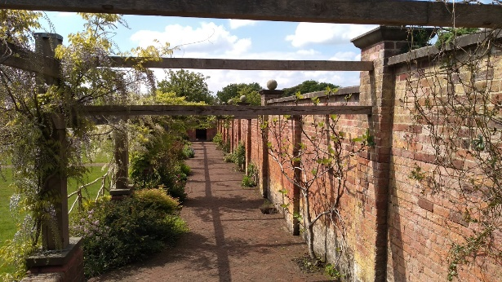
  - There is strong support for policies that encourage people to be healthier and provide opportunities to be more active. Through the design of development, the Local Plan can look to incorporate some of the ides proposed, as well as also looking at the existing evidence base in the Open Space and Sport Recreation Assessment (OSSRA) to see what additional facilities are needed across the plan area which should be brought forward through the Local Plan.
The Walled Orchard, Cuerden Valley Park

Question 44
  - Question 44 asked ‘How can the Local Plan improve our existing homes?’. There were 300 responses. The main themes were:
- Ensure all homes (including existing) are made energy efficient and are adapted to climate change, and promote the benefits of this.
- Ensure homes are built to a good standard.
- Ensure energy to heat homes is affordable for all.
- Provide adaptable homes to enable people to stay in homes longer.
- Make better use of empty homes/buildings but also stop overcrowding of homes.
- Design areas to include sufficient parking and provide green space/green infrastructure (GI) and waste recycling.
- Establish community owned and co-operative models of housing and electricity generation and develop more Council housing
- Consider how people live beyond their own homes, and how they can improve them.

Question 45
  - Question 45 asked ‘What can the Local Plan do to promote healthy neighbourhoods?’. 331 responses were received which raised the following key points:.
- Tackle social isolation and build community hubs/centres to support and publicise community projects and engagement through classes/activities,
- Provide linked green spaces, parks, leisure facilities etc. Make them accessible for all and advertise them.
- Improve walking and cycling and stop on pavement parking
- Utilise the waterways and blue spaces like the River Ribble and Preston Docks.
- Ensure physical activity and the Ten Principles of Active Design run throughout the plan.
- Provide infrastructure and more services, including for mental health. Support people with dementia by designing simple housing layouts and signage.
- Build in sustainable locations and provide local shops, schools and sports activities close to new housing.
- Provide more social/affordable housing.
- Implement zero carbon energy and transport and improved public transport to reduce traffic and pollution, and manage traffic better.
- Integrate nature into development by embedding them with green infrastructure.
- Build away from major roads and industry.
- Provide clear guidance about the amount of open space required in developments.
- Don't overdevelop and destroy countryside/the Green Belt and greenfield sites. Develop brownfield sites instead.

Summary and Findings
  - A number of the comments raised here have also been identified in earlier sections regarding housing locations. However, specific comments on the need for more leisure and sports space and building inclusive communities are highlighted in the responses above.

  - As with points elsewhere, the importance of the green space around our towns needs to be recognised and protected for the value it has to the local communities. The Local Plan should invest in protecting and enhancing this and the habitats it supports as well as the wider health benefits they provide.

Question 46
  - Question 46 asked: ‘Do you think there are enough community facilities, such as public houses, local shops, meeting places and cultural buildings in Central Lancashire?’. 408 people answered this and 164 people answered ‘yes’ with 244 saying ‘no’. Some responses were provided which referred to the importance of infrastructure capacity, a lack of shops in Bretherton, and that the Local Plan should consider the overall value of community facilities.

Question 47
  - Question 47 was a supplementary question and asked ‘If not, how do you think we could attract more and where should they go?’. 233 responses were received which raised the following key points:
- Should be driven by neighbourhood plans.
- All new housing sites need to provide a range of facilities.
- Invest in libraries especially, Youth Zones/clubs, Sure Start Centres and exhibition spaces and use co-operatives and the voluntary, community and faith sectors. Ask young people what they want.
- Provide leisure facilities as useable in poor weather, and sports facilities/clubs
- Use buildings that are not available in the day in the evening for community use and encourage cafés to open in the evening. Provide mixed use/joint use spaces/facilities. Make better use of existing empty buildings.
- Control national chains and supermarkets that threaten small businesses.
- Encouraging small developments close to existing settlement centres will reverse the decline in local facilities.
- More cultural facilities are needed.
- Regenerate town centres to encourage facilities to open in smaller neighbourhoods.
- Support facilities through encouraging entrepreneurism, reducing rents and rates and providing grants and subsidies.

Summary and Findings
  - There is clear support for the development of additional community facilities for towns and villages across Central Lancashire. It is noted that facilities are required in existing towns and villages and not necessarily as a result of new development. In relation to new development, existing facilities should be protected and development should seek to enhance the offering in an areas and ensure all sectors of society are catered for. The ability of existing facilities to cope with increased demand from new development should also be considered.

Question 48
  - Question 48 asked: ‘How can the Local Plan provide employment opportunities to all in society, to improve health and well-being?’. There were 865 responses. 171 of which had an issue or opinion to raise, while 694 stated ‘N/A’ or had no comment or opinion, similarly, 14 stated they did not know enough to comment.
  - Some stated that the Local Plan could not deliver this at all, with commercial organisations or central government cited as the key drivers behind this.
  - Ideas around empowering employers and employees to improve health and well-being included:
- Co-locate offices and industry alongside housing to reduce commuting times and unemployment and avoid areas becoming dormitory towns to larger areas.
- Promote and invest in local businesses/SMEs and locally sourced employees (as opposed to larger, national or international ones).
- Promote industries and careers in the high-skilled technology, advanced production/manufacturing/construction and science sectors.
- Allocate land specifically for health and well-being employers.
- Establish more publicly supported schemes and units like the Strawberry Fields Digital Hub.
- Provide training and apprenticeships as routes into work.
- Support local manufacturing employers.
- Improve links between leisure and sports providers and employers.
- Recognise the link between gainful and meaningful employment and well-being.
- Improve accessibility in public spaces and employer premises for the disabled.
- Improve public transport links between homes and workplaces to better connect employers to residents.
- Support start-up/pop-up businesses and a variety of alternative employer models by easing planning consents and.
- Encourage locally grown food providers, healthy produce outlets and promote healthy diets.
- Provide a mix of housing tenures for a wide range of groups, especially key workers (i.e. shared ownership, affordable housing).
- Allocate space for less restrictive mixed use to co-locate offices / warehousing / SMEs /services together to provide a range of services to any area.
- Ensure a wide range of employment is available not just to the highly skilled, but to people with families, the disabled, those with learning difficulties, the elderly, those on low-incomes, those not in employment, education or training (NEETs) and the homeless.
- Have a policy target of a Central Lancashire employment rate (i.e. 95% over the plan period).

Summary and Findings
  - There are a clearly a number of areas that in which employment opportunities can assist in improving health and well-being. The points raised above identify areas where the Local Plan needs to work collaboratively with local education providers and businesses to ensure that increased opportunities are provided for those living in the area to gain meaningful employment.

Question 49
  - Question 49 asked: ‘Do you think the support for co-operatives in Central Lancashire is a good thing?’. 309 people answered this and of those 277 answered yes which is almost 90% of respondents.

Question 50
  - Question 50 was a supplementary question and asked: ‘If so, how can the Local Plan support them so that they flourish?’ (Co-operatives in Central Lancashire). There 140 responses to this question. A summary of the key themes and issues within these is outlined below.
  - Respondents commented on a range of Social Enterprise (SE) ventures in their responses, not only Co-operatives. ‘SE’ below covers Co-operatives, Community Investment Companies, Voluntary Organisations and Worker-Owned Companies.
- Halt and avoid the loss of local SEs in Central Lancashire and support all forms of them and not-for-profit organisations and ventures.
- Free or Low cost vacant or variable units should be made available to let.
- Simplify the planning application process or help with the granting of planning permission/planning consent and provide an easier, fast-tracked process for SE licensing.
- Publicise and promote the SE model, encourage investment into them through the ‘Preston Model’.
- Ensure SEs are accessible and near public transport routes and stops.
- Promote the co-location of SEs together with co-housing solutions, affordable housing, allotments etc. to encourage continuing community involvement and usage.
- Promote SEs in rural areas or villages where they can be most impactful.
- Establish a 'Co-operative Zone' akin to an 'Enterprise Zone'.

  - Ideas around recognising the wider impact of co-operatives and SEs included:
- SEs promote sustainable values of green living and local produce, use them as a vehicle for climate change.
- Recognise the positive benefits of collective operation to a community and get them involved, allow SEs to meet local needs and combat social isolation.
- Recognise that a range of services can be delivered by SEs, housing & construction, child care, community transport, social care and retail.

Summary and Findings
  - The above responses identify support for and expansion of existing co-operative/social enterprises as well as creation of new ones. There are linkages identified between the existing organisations available across Central Lancashire and the growth of SME’s in those locations. There is a clear need to make it easier for SME’s to get going and the Local Plan should foster the opportunities to learn from those in existence and work with organisation to provide more opportunities going forward.

Climate Change & Resource Management

  - This section of the consultation document covers the issues of climate change, waste management and sustainability, air quality, natural assets, design and the built environment. There are 10 questions covering the potential issues for the Local Plan around these topics. This section presents a summary of the key themes identified, with a detailed analysis presented in Appendix 5.

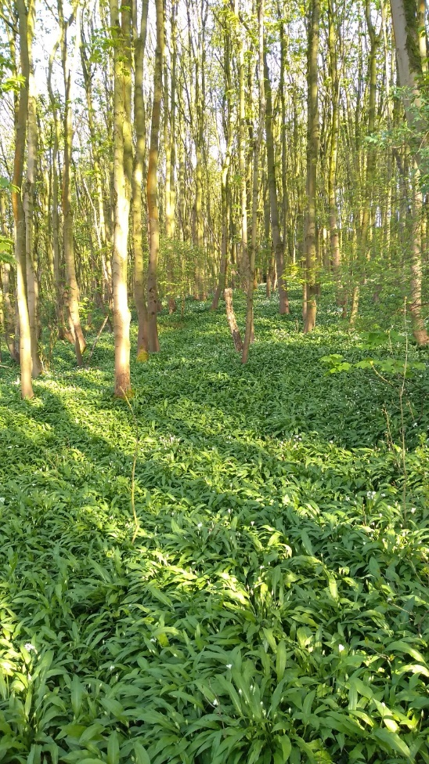
  - The first question in this section set out a number of ways the Local Plan can play a part in addressing Climate Change, these are set out again below:
- Effective master planning of new large-scale development areas, to combat future climate change issues.
- Having better policies on design of new buildings/extensions/places which support the use of low carbon design approaches which can make places more energy efficient, and consider the importance of passive solar design, which is about the direction a building faces to maximise the use of the sun’s energy for heating and cooling.
Abbot’s Wood, Walton-le-Dale
- Consider the use of decentralised energy networks where new facilities are being planned close to housing or employment uses, and how to design development to maximise the use of this energy and heating source.
- Work with Lancashire County Council to provide more sustainable transport options; including provision for electric charging points in all new developments and in all existing and planned car parks to ease the move away from conventional fuel vehicles.
- Requiring energy performance standards for new housing or the adaptation of buildings to provide dwellings, that are higher than the building regulations.
- Design all developments to reduce the need to travel by providing green infrastructure which connects to wider cycling and walking networks and other open spaces.

Question 51
  - Question 51 asked of the above ‘Is there anything else that the Local Plan can do to address Climate Change?’. A total of 349 responses were received to this and the key issues raised are summarised below.
- Design areas to reduce reliance on car use and invest in improving existing public transport provision across the area, including a move to clean buses and trains and widening the area served. Need sustainable transport to be promoted and put walking and cycling at the top of the hierarchy.
- Embrace the ideal of the circular economy and reduce waste and recycle better.
- Climate change issues are far reaching and to deliver change we will need to work collaboratively with other authorities and organisations. Climate change will need to be embedded throughout the plan to ensure due consideration is given to this issue.
- Protect green areas for the role they play in carbon storage and supporting clean air.
- Need to reduce energy use.
- Promote the green economy and green businesses moving into the area. Ensure all new development is carbon neutral.
- Lead by example and install green solutions on public buildings including solar/wind for power and water harvesting.
- Need for creation of more green space across the plan area, and specifically in new developments. They should be required to provide a minimum amount of green space. Tree planting should also be required on new developments and considered alongside main roads.
- Support for a clean emissions zone for Central Lancashire.
- Recognise the need for all homes and buildings to be energy efficient (including existing stock) and built to at least Building Research Establishment Environmental Assessment Method (BREEAM) standards, and to support move away from gas heating in new homes.
- Avoid areas of flood risk and design areas to avoid hard surfaces creating surface water flooding. Sustainable Urban Drainage is needed for all new developments as well as efficient drainage systems.
- Support the move to Electric Vehicles by providing charging points to new homes / in car parks etc. Also need to consider how these can be provided in areas where there is no driveway – incorporating charging points in street furniture for example.
- Support for creation of more allotments and community growing spaces.
- Plan needs to be clear on what its expectations are, regarding delivering biodiversity net gain in all new developments.
- Need to invest in road infrastructure to reduce congestion points and CO2 emissions.
- United Utilties (UU) recognise the need for climate change to be factored in to master planning of all large-scale developments and ensure the effects of climate change are considered at the earliest stage. UU also suggest inclusion of specific policies for flood risk and surface water management.
  - The issues raised cover a number of areas where policies will need to be developed for the Local Plan. The importance of tackling this issue through the Local Plan is understood by the councils, as well as through wider initiatives being delivered locally. The Local Plan will need to work with other areas and agencies to deliver the carbon reduction goals and ensure that development is considered carefully and well designed/planned. Where issues cross boundaries, we will need to ensure that neighbouring areas are working with us to address them.

Question 52
  - Question 52 asked ‘How can the Local Plan help to increase tree and woodland planting?’.

  - There were a total of 393 responses to this question. The key themes emerging from this response are outlined below.

- Many felt that more trees should generally be planted wherever possible, and that the species of tree is important for the location, especially native varieties to support local biodiversity.
- Suggestions were made to support species-rich grassland/semi-improved grassland/wet grassland/blanket bog/moss land to promote biodiversity and carbon capture and storage.
  - In terms of the best areas for planting, suggestions included:
- In towns/cities/residential areas (to reduce pollution), including ‘living walls’.
- At the edge of existing woodlands and improve green corridors between woodlands.
- Along parish or local authority boundaries.
- Alongside roadside verges (in particular; A585 / A59 / A6 / Penwortham Bypass / Western Distributor / new roads).
- In ‘Pocket Parks’ or small planting schemes in built-up areas with little space.
- On Glebe Land or land owned by parish councils.
- On council-owned public land (and designate new land for this use).

  - There were many suggestions as to how the councils could directly deliver or support tree planting, including:
- The employment of a specialist tree officer/arboriculturist or a dedicated tree department.
- Work with voluntary/environmental groups to plant and maintain woodlands.
- Seek wider engagement with the Woodland Trust or Lancashire Wildlife Trust.
- A commitment to reduce carbon emissions to which tree planting would contribute.
- Avoiding the loss of existing trees.
  - Ideas for development control policies to shape the future provision of trees in the area included:
- Requiring trees to be planted in every new-build house garden or a quota across the site and like-for-like replacement of trees felled for development.
- Policy commitment to a stated target number of trees or a period of planting.
- Not permitting development in areas with existing woodland/grassland/Green Belt/recreation.
- Protection/active management and expansion of existing woodlands.
  - There is clear support for managed planting to take place across Lancashire. The species chosen need to be carefully considered to ensure they marry well with the existing woodlands and enhance the biodiversity of an area. There is support for policies in the plan to stipulate the need and coverage of tree planting in new development and to consider use of this in improving air quality along main routes.

  - Questions 53 to 55 looked specifically at the provision and delivery of waste and recycling containers to new developments and how these should be provided.

Question 53
  - Question 53 asked ‘Do you agree that the Local Plan should include a policy asking developer to arrange and pay for the provision and delivery of waste and recycling containers to new build properties?’. There were 420 responses to this question, 86% were in favour of this and said yes they should, whilst 14% said no. Further responses submitted in relation to this question noted that Local Authorities have a duty under the Environmental Protection Act 1990, to collect household waste and to meet relevant recycling and composting targets and this work is funded by council tax receipts, as such this should continue to be the case.

Question 54
  - Question 54 went on to ask ‘If you agree, should this arrangement apply to only major development (over 10 homes for example) or all developments?’. 366 responses were received to this question. 14% felt this should only apply to major development, with 86% stating it should apply to all development.

  - Additional comments made in relation to this question stated that once purchased, houses become the property of the owner and they are responsible for its management and will pay council tax on the property to the local authority, which covers the managed collection of waste from households.

Question 55
  - Question 55 asked ‘If you disagree, please explain why. There were 122 responses to this question and the key points raised have been summarised below.
- Many felt that developers would simply pass the charges back to the houseowner and it would be a disincentive.
- Householders already pay council tax, therefore cost should come from this.
- Developers should provide more to the communities in which they build, not just those who choose to buy a house.
- New homes should not be treated any differently from existing householders who have to buy their own.
- It is the councils’ responsibility, not the developer to provide bins and not the role of the Local Plan.
  - There is a mixed view on how provision for bins in new developments should be provided, but it is not felt it is the role of the Local Plan to manage this. These responses will be shared with colleagues in waste management.

Question 56
  - Questions 56 to 58 looked at the issue or air pollution across Central Lancashire and what the Local Plan can do to tackle this. Question 56 asked ‘How can the Local Plan help improve air quality?’. A total of 350 responses were received to these questions, and the key themes identified have been summarised below.
- The Local Plan needs to support the move to the electric vehicle.
- Less development overall to reduce issues.
- Consider traffic restrictions on local roads to reduce HGV traffic and car free days.
- Invest in clean/green public transport and make it a viable alternative to the car. Also look at providing more park and ride facilities.
- Avoid development in Air Quality Management Areas (AQMAs) and housing adjacent to main roads.
- Better planning/designing of areas to design out reliance on cars to encourage move towards sustainable travel. New developments must have a designated percentage assigned to provision of green/community spaces and include tree planting.
- Need a Local Cycling and Walking Infrastructure Plan.
- Incentivise the use of renewable energy in all new development.
- Introduce clean air zones and monitor emissions better.
- Tree and wildflower planting on road sides and central reservations, and protect existing trees and hedgerows from loss due to development.
- Air quality crosses boundaries, therefore work with others to address this issue.
- Make all homes and building energy efficient and provide new homes and employment areas close together to reduce travel. New development should be required to provide carbon offsetting in the local area.
- Development should be designed to minimise or prevent increased air pollution. Air Quality Assessment should be submitted with all major applications.
- New development should only take place on brownfield sites close to public transport links.
- No energy from waste developments and less reliance on fossil fuels.

Question 57
  - Question 57 asked ‘How should the Local Plan seek contributions from new development to improve air quality?’. A total of 253 responses were received in respect of this question and the key issues raised are summarised below.
- Developer contributions should be identified as part of the Plan.
- Provision of green infrastructure – walls/roofs in new developments.
- Developers should be required to provide electric vehicle charging points and renewable energy options for powering/heating homes and buildings.
- They should be required to design in sustainable transport options and provide funds to deliver/support local services operating in the area.
- Consider a green tax for new properties payable by developers. The greener the development, the lower the tax.
- Consider use of section 278 agreements on highways.
- Consider developing a Low Emissions and Air Quality Advisory Note, to be adopted as an SPD, as in the case of Lancaster.
- Community Infrastructure Levy (CIL)/Section 106 should only be sought in line with requirements set out in the NPPF. Air Quality would not meet these tests as it is not the role of the developer to solve existing issues.

Question 58
  - Question 58 looks specifically at smoke emissions and asked ‘How can the Local Plan reduce smoke emissions?’. There were 207 responses to this question and the key issues raised are set out below.
- This is not the role of the Plan and dealt with through existing regulations.
- Ban the sale of non-compliant stoves and their fuel, and do not allow them in new homes.
- Consider use of clean air zones and invest in research for clean fuels.
- Offer better recycling options and change criteria for access to recovery and recycling centres (RRC’s) to reduce burning of waste illegally – ban bonfires.
- Incentive the move to electric vehicles and renewable energy and require clean/green public transport.
- Particulates are a huge issue and the councils need to monitor and address this.
- Protect green areas, tree and hedgerows being lost through development, and provide more green spaces.
- Develop employment and housing opportunities close together to reduce the need for travel.

Summary and Findings
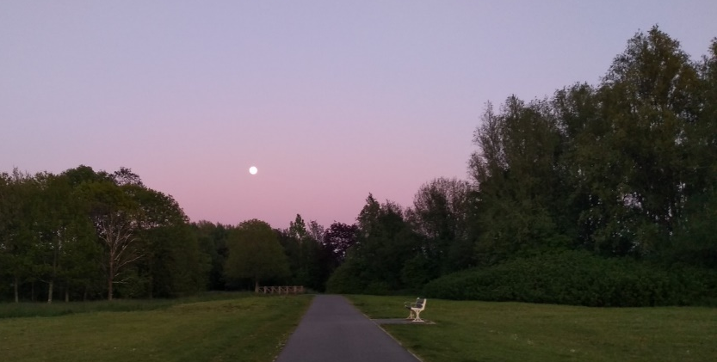
  - There are clearly a number of issues which need to be addressed to ensure air quality is improved across Central Lancashire. A clear theme through all the questions is the need for more joined up planning when identifying areas for housing and employment to reduce travel and dependence on cars. In keeping with responses elsewhere, the issue of better public transport has been raised again, and the desire for this to be clean/green travel. Also providing safer and dedicated areas for cycling and walking is raised.
Withy Grove Park

  - There is general concern that development will adversely affect air quality, and air quality assessments will be needed to support all major applications. New development needs to be greener, promoting renewable sources for power and heating and sustainable building practices. Developments need to provide dedicated green spaces for the communities living there to use, and in built up areas consider making better use of space and incorporate ideas such as green roofs and walls, but overall improve the green infrastructure provided.

  - There are a number of points raised in response to the questions posed and these will be used to help formulate policies for the Local Plan.

Question 59
  - Question 59 considered issues regarding the wider environment and asked ‘Are there any specific issues that the Local Plan needs to address regarding the environment?’. There were 274 responses received for this question and the key themes identified are summarised below.
- The Local Plan needs to design areas to reduce reliance on cars and promote the use of sustainable travel modes.
- Less development and instead protect the green areas, trees and hedgerows and habitats they provide for supporting local biodiversity.
- Need to provide better alleviation for flood risk areas and design areas better to prevent future instances of flooding – do not build in areas of flood risk.
- Ensure important local heritage is considered and protect the character of areas when considering new development.
- Provide more green space through the Local Plan to enable healthier lifestyles.
- Protect and introduce more ponds and require biodiversity net gain.
- Consider involving youth more and establishing a youth committee.
- United Utilities are concerned about large allocations in multiple ownerships with interconnecting infrastructure issues.
- Natural England highlighted a number of issues to be considered in the Local Plan for the protection, conservation and enhancement of natural assets.
- The Environment Agency raised the need to acknowledge the health benefits of the environment and the improvements needed to both Green Infrastructure and Blue Infrastructure. Need to establish a Nature Recovery Strategy to ensure biodiversity net gain can be delivered.

Question 60
  - The last question in this section looked at design and built and historic environment. Question 60 asked ‘How can the Local Plan achieve high quality design?’. A total of 255 responses were received and a summary of the key issues identified is presented below.
- The Local Plan needs to set out required design standards and condition applications to deliver this. Make refence to National Design Guide 2019 and the Building Better, Building Beautiful Commission.
- Need to build requirements for nature conservation into good design and sustainable building practices.
- Need to consider how infrastructure needs can be delivered when designing areas.
- Use experts and train planners and members about good design.
- Ensure the existing character of an area is maintained and make use of local materials in keeping with the area.
- Ensure consultation with local people so they can be involved in how developments will look.
- Provide more outdoor space and adequate internal space.
- Site design policy needs to incorporate multiple benefits within overall design and be clear about what is expected of developers so they can cost builds accordingly.

Summary and Findings
  - The responses indicate that the design of developments needs to consider a number of factors, but it is clear that good design must be considered early in the planning process and incorporate the need to protect and enhance the natural environment. The Local Plan will also need to be clear what is expected from new development regarding the need to deliver biodiversity net gain.

  - The Plan will need to work closely with specific bodies/organisations over the issues identified and what needs to be included in the policies to be used to manage development over the next 15 years. It should also work closely with local communities affected by development to ensure that what is delivered is in keeping with the local area and is acceptable to those living there.

Locations for Future Development

  - The final section of the Issues and Option document considered locations for future development. There were 8 questions posed, with 4 of those looking specifically at site suggestions which the three councils had received. There were also some more general locational questions asked, which looked at the existing approach to locating development in the Adopted Core Strategy. The methodology to be used to assess sites is also discussed, as is the approach to identifying safeguarded sites in the new Local Plan. The key themes identified are summarised below, with a more detailed breakdown presented in Appendix 5.

Question 61
  - The first question in this section is question 61, which asked ‘Is the Core Strategy approach (set out in paragraphs 8.6 &8.7 above) providing the homes, jobs and facilities that are needed?’. Of the 384 people that responded to this question, 64% said no it doesn’t and 36% said yes. Some respondents submitted further comments in relation to this question, and they are summarised below:
- Support the Plan being flexible in areas where development will take place to help sustain existing communities and meet their needs.
- The Core Strategy does not provide the best locations. The Local Plan provides an opportunity to readdress this and identify the most appropriate locations for growth and development.
- Housing requirements (policy on distribution) cannot be determined until true aggregated housing need (policy off) has been determined.
- It is important to recognise the contribution that sites in smaller settlements or in rural locations can make to housing supply. The Plan should not place undue restrictions on locations for new development which could stifle development and investment in the area. Protection of the environment needs to be balanced with the social and economic needs of the area.
- The NPPF emphasises the need for planning policies to create conditions in which businesses can grow. The Plan should not place undue restrictions on locations for new development which could stifle development and investment in the area.
- The Core Strategy is not reflective of growth aspirations of Central Lancashire.
- The Local Plan needs to consider City Deal requirements.

Question 62
  - Question 62 asked ‘Where would you like to see the Local Plan focus new homes and jobs in the future? There were 506 responses received to this question with the key points raised summarised below:
- Development should be focused on brownfield land.
- Look to regenerating existing buildings first and make use of redundant commercial buildings. Need to repurpose our town and city centres.
- Development should be within or close to, the main towns and large urban areas where infrastructure is in place and reduces the need to travel. Locations need to be close to transport links and employment.
- There needs to be a fair distribution across the area. Need to make sure employment is also delivered alongside housing to prevent areas becoming commuter towns.
- Need to maintain separation between towns.
- No more development is needed, the area is already overcrowded.
- Need to avoid areas of flood risk.
- Use guidance set out in the NPPF.
- Need high value jobs. Look at expanding existing commercial and employment sites to deliver this need.
- Prioritise areas delivering the City Deal.
- Government objective to bolster housing supply and support economic growth should be at the forefront of the spatial strategy.
- Need robust transport evidence and modelling for the whole plan area and allocations should focus on delivering sustainable travel. Any highway improvements should be identified in the Local Plan.
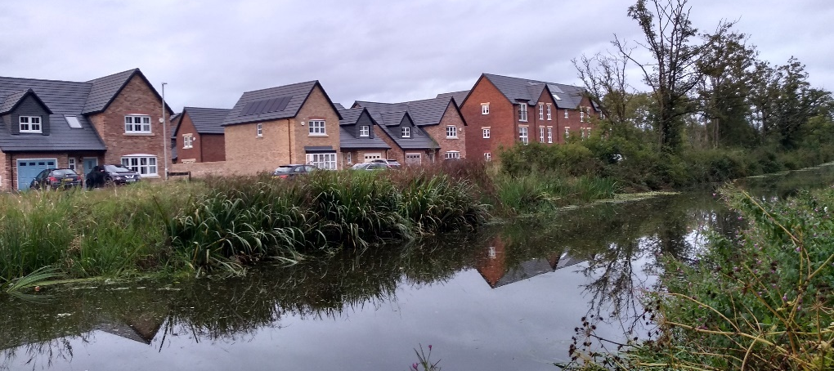
New Development in Cottam

Summary and Findings
  - The responses to questions 61 and 62 have identified a number of areas which need to be considered when locating future development across Central Lancashire. The responses highlight the need for any sites to help achieve sustainable growth for the area whist still providing the necessary homes and jobs required. We need to carefully consider the location of both employment and homes to ensure accessible and sustainable locations are identified.

  - We need to ensure the evidence base developed for the Local Plan provides the information needed to enable decisions on where development is needed to be made. The comments made relate to a number of documents in preparation, as well as updates to existing work. Once complete, the evidence base will be used to guide the location of future development.

Question 63
  - Question 63 of the consultation asked ‘Do you have any comments to make about the SHELAA methodology set out in the Report in Annex 7?’. There were 197 responses to this question.

  - Many of the responses commented specifically about the methodology itself, whilst others focused more on the process of how the methodology has been applied so far (i.e. the exclusion of various sites in Chorley from Annex 5 which are shown in Annex 1). The main points raised are summarised below:
- The recommended minimum site threshold for sites to be included in the SHELAA should be 5 dwellings or more, as recommended in Planning Practice Guidance (PPG).
- There should be a specific requirement to deliver at least 10% of the requirement on small and medium sized sites. Also widen it to sites over 1 hectare as these too can provide a boost to supply.
- Decisions on the spatial distribution of future housing needs and on the exclusion of potential sites have been made prematurely in advance of the full evidence base. The SHELAA assessment should not determine whether a site should be allocated for development – it should just provide information on the range of sites which are available. The methodology should be amended to reflect this.
- There is a need to increase the level of rural development, to allow for economic growth of rural services and facilities, enable villages to grow and thrive, and increase choice/local housing supply.
- The current approach is contrary to PPG for protecting Green Belts. A Green Belt review should not take place until all other reasonable options for meeting identified development needs have first been considered.
- No criteria has been provided to explain how sites considered will be assessed in a consistent manner. Clarity is needed for how Annex 5 was reduced to Annex 1. The approach is not appropriate or in accordance with national guidance.
- The housing need should be established first, before sites are assessed. It should identify where and what type of housing is needed first, and then seek sites in those areas.
- Sustainability of the site and immediate area should be a key component of the sieving process, with a matrix which scores the site.
- Need more emphasis on employment, recreation and other uses.
- The assessment needs to be independent and transparent. How this will be done? The next stages/consultation need to be made clearer in the methodology. Communities should have more say on which sites come forward.

Summary and Findings
  - The approach of the SHELAA, to identify a sufficient amount of available, suitable and achievable sites to meet the identified local housing and economic needs of the area, was generally supported. However, some concerns were expressed that the methodology was not following national guidance. The SHELAA methodology will therefore be reviewed to ensure it aligns with national policy and guidance, and that all sites are assessed accordingly.

  - A number of points have been made regarding the approach set out in the SHELAA. The Local Plan team will consider all points made in determining the final criteria to be applied when assessing sites.

Questions 64, 65 and 67
  - Questions 64, 65 and 67 sought comments in relation to all the locations for development in Central Lancashire across the four Annexes dedicated to the presentation of site suggestions. All sites were mapped in Annexes 3, 4 and 5 to the Issues and Options consultation document; Annex 5 related to sites for Chorley, Annex 4 for South Ribble, and Annex 3 for Preston, with Annex 1 providing a refined list of site suggestions for consideration by Chorley Council (but only from those presented in Annex 5).
  - As part of the call for sites, a number of suggestions were put forward for sites to be considered for Protection by residents across all three council areas. Appendix 3 provides details of all sites suggestions and the responses received in relation to them through this consultation, and also highlights those areas of Central Lancashire where specific requests for protection have been received. Were submissions for protection have been received, this has been noted against any corresponding site suggestion which will be assessed through the SHELAA process.

  - The responses can be broken down as follows:

  - The responses to all the site suggestions, regardless of specific site or local area to which they specifically related, were generally from local residents against development and focused mainly on the housing proposals. However, there were contrasting comments from developers in support of development and through provision in some cases, of detailed documents in support of specific site suggestions.

  - The key issues and concerns raised against the development of specific sites included:
- Increased demand for amenities, private and public services in areas that are already stretched, at capacity or have historic undersupply of service (i.e. doctors, schools, hospitals, banking, retail).
- Loss of greenfield land and/or erosion of the Green Belt.
- Highways issues, particularly around access and narrow country lanes.
- Many areas already at risk of flash or seasonal flooding, development will worsen this and create a knock-on effect in nearby areas due to surface water run-off.
- Local needs should be met, particularly for affordable/social/specialist or sheltered housing.
- Impact of the character and identify of areas.
- Loss of environmental assets and impact on local habitats, biodiversity hotspots or endangered species or seasonal/migratory species.
- Loss of agricultural land, leading to the loss of healthy, local produce, rural jobs and impact on rural economy and farmland habitats for wildlife.
- Increased road journeys, roadside parking and traffic
- Pressure on already overstretched or at capacity road, rail or blue infrastructure.
- Brownfield alternatives should be considered e.g. Camelot, Botany Bay, in-line with brownfield targets.
- Pressure on already overstretched utilities, including gas, water, broadband, electricity, drainage, sewers/foul drainage and fire hydrants.
- Fragmentation of wildlife corridors and connected greenspaces, reducing the mobility of deer, squirrels, badgers, foxes and hedgehogs.
- Increased carbon footprint of the local area and failure to achieve carbon neutrality targets set by the local planning authorities.
- Infill or settlement boundary sites will unlock adjacent land and lead to ribbon development, further eroding greenspace.
- Harm or destruction of a locally/nationally listed building or heritage asset.
- Harm to an on-site or nearby ancient woodland or protected trees (TPOs).
  - Many comments were however, in favour of development where it could be shown that needs were fulfilled, impact could be mitigated, or the benefits were clear.

  - The key issues and ideas raised in favour of development of specific sites included:
- Infrastructure improvements, including transport, greater diversity of shops, services and restaurants in the area. This can boost rural areas for example and help make smaller settlements/villages more sustainable.
- Meeting local housing needs and offering choice for affordable units, mixed tenures, sheltered units for the homeless and specialist housing.
- Co-located housing and employment opportunities.
- New sports and leisure facilities.

Summary and Findings
  - A large number of concerns raised about specific development proposals referred to the impacts on existing stretched infrastructure, and the loss of greenfield / Green Belt land, including adverse impacts on the character of areas, highway congestion/safety, and local amenity.

  - Conversely, many of the issues raised in favour of specific development proposals referred to improvements to the local infrastructure that development, particularly larger schemes, would bring, as well as meeting local needs and improving the area’s amenity and accessibility.

  - Further work will now be carried out as part of the Local Plan process, underpinned by the evidence base and any further studies, to ensure the most suitable, available and achievable sites and locations are brought forward to meet the identified needs of the area, including local and specialist needs. All site suggestions will be subject to a rigorous site assessment process, informed by Strategic Housing and Economic Land Availability Assessments and Sustainability Appraisal of options. These will be presented and consulted upon at the Preferred Options stage of the Local Plan process.

Question 66
  - Question 66 asked ‘Do you agree that Chorley should not have a policy for safeguarded land in the new Local Plan?’

  - Of the 382 respondents expressed an opinion for this question, the majority of these (75%) answered ‘no’ (i.e. that there should be a safeguarded land policy in the new Local Plan), whilst a minority (25%) answered ‘yes’ (i.e. that there should not be a safeguarded land policy in the new Local Plan). Additional comments made in relation to the response were also received and are summarised below.

- Safeguarded policies are there for a reason which is to ensure that a future pipeline of available land can be identified in future Plans, but should also be considered for early release if needed, to meet localised need.
- Safeguarded land allows the Councils to be responsive to future development pressures in meeting land supply targets.
- Sites already identified as safeguarded should be released for development from the Green Belt and it will be necessary to identify additional safeguarded land to provide assurance of a longer term ability to meet needs beyond the end of the Plan period.
- The Council should have a policy for safeguarding land to protect areas of conservation value and Green Belt from development.

Summary and Findings
  - The responses highlight a level of support for maintaining a policy for safeguarded land. However, the reasoning behind this differs, with developers looking at this to guide where future development is likely to take place and identify areas for future investment, and on the contrasting argument, local residents seeing this as a protective policy which will prevent areas being developed. The need for a policy about safeguarding land will be considered through the development of the plan, and any wording supporting such a policy will be carefully considered to ensure it is clear what the purpose of such a policy is.

Question 68
  - Question 68 asked ‘Do you have any further comments that you wish to make?’

  - There were 314 responses to this question covering a number of policy ideas, key issues and Local Plan associated themes emerged which have been summarised below.

  - Given the breadth of the final question and the final opportunity to comment on the survey, responses varied significantly in length, scope and topic, and ranged across all issue themes covered in Questions 1 to 67. As such, many were repeat suggestions and are not duplicated here. Responses that presented unique concerns, issues and opinions not covered earlier in the report are summarised below.

  - Issues around future consultation and the Local Plan process more widely included:
- A Green Belt review during later stages should be done with full transparency, in compliance with central policy and consulted on widely.
- Give greater weight to residents and communities against the well-funded developers/consultants and their legal teams.
- Greater face-to-face engagement within local communities throughout the planning processes.
- Recognise the needs of the growing Black Asian and Minority Ethnic (BAME) community , especially in creating space for Places of Worship.
  - Issues around locating development included:
- The proposed Memorandum of Understanding (MOU) about distribution of housing numbers would lead to overdevelopment/inappropriate development in many areas.
- Plan for ambitious growth, to both exceed minimum housing targets and strive for economic parity with Merseyside and Greater Manchester.

  - Residents and stakeholders’ issues related to the economy and growth included:
- Adapt centres toward vibrant, integrated centres for retail, services, culture, leisure, housing and transport hubs.
- Identify/allocate land for future education development.
- Expand Policy 14 to include further education/higher education providers or have separate policies for different levels education development.
  - Issues that focused on land, climate, trees and quality of life for residents included:
- Recognise trees classed as ‘ancient’ or ‘veteran’ are irreplaceable and important for wildlife, soils, recreation, cultural value, history and contribution to landscapes.
- Give farmland over to renewable energy generation.
- Co-location of health services within new developments.
  - Issues around the siting and controlling the scale and scope of development and site proposals included:
- Identify new areas of safeguarded land between the urban area and the Green Belt to meet future development needs into the next plan period.
- The allocation of a Garden Village would enable the Central Lancashire Authorities to create a bespoke settlement that provides a range of community facilities suitable to fully meet the needs of proposed residents.
- Recent changes in the local economy and the way in which people are working supports a more dispersed approach to locating future growth.

Summary and Findings
  - In summary a wealth of ideas across all themes in the Issues and Options consultation were contained in this final question, adding unique perspectives and points on issues ranging from development opposition, control, mitigation, support and the policies that underpin such measures. All points will be fed back into their respective policy theme areas and will be used alongside the main response issues and ideas in those sections to form a comprehensive basis on which emerging policy will draw upon.

  - A number of responses to this final section also commented on the consultation itself, suggestions were made more generally about how stakeholder and resident engagement could both improve for future consultations and for the Local Plan more widely, in terms of ensuring compliance with national strategy, effective cooperation with our partners and ensuring soundness throughout.

Conclusions and next steps

  - The Issues and Options consultation received a considerable response from a number of sectors and has proven successful in gaining awareness of and interest in the development of the Local Plan. It has provided the councils with a good level of views in response to the questions raised, the site suggestions consulted on, and the areas to be considered for development as part of the emerging evidence base for the Plan.

  - There was a good level of response received to the site suggestions, the detail on specific response per site is provided in Appendix 5. Many respondents provided detailed and well thought out comments, identifying particular issues of relevance to the area. Responses were received for and against the site suggestions, all of which will be used to aid assessment work and consideration of the approach to be developed for the Local Plan.

  - A number of comments asked for further detail to be provided in evidence base documents in order for due consideration of development impacts to be made. Comments were also made about the publicity of the consultation and the online nature of the consultation through the use of Citizen Space. Although the consultation undertaken was in line with the Statement of Community Involvement prepared by each of the three councils, the concerns raised have been noted and consideration will be given to how we can assist communities better in future engagement work, ensuring their involvement in the development of the Plan.

11.4 A number of key themes identified cross over into a number of areas of the consultation document, and work to address these points will be looked at as we continue to review and update the evidence base.

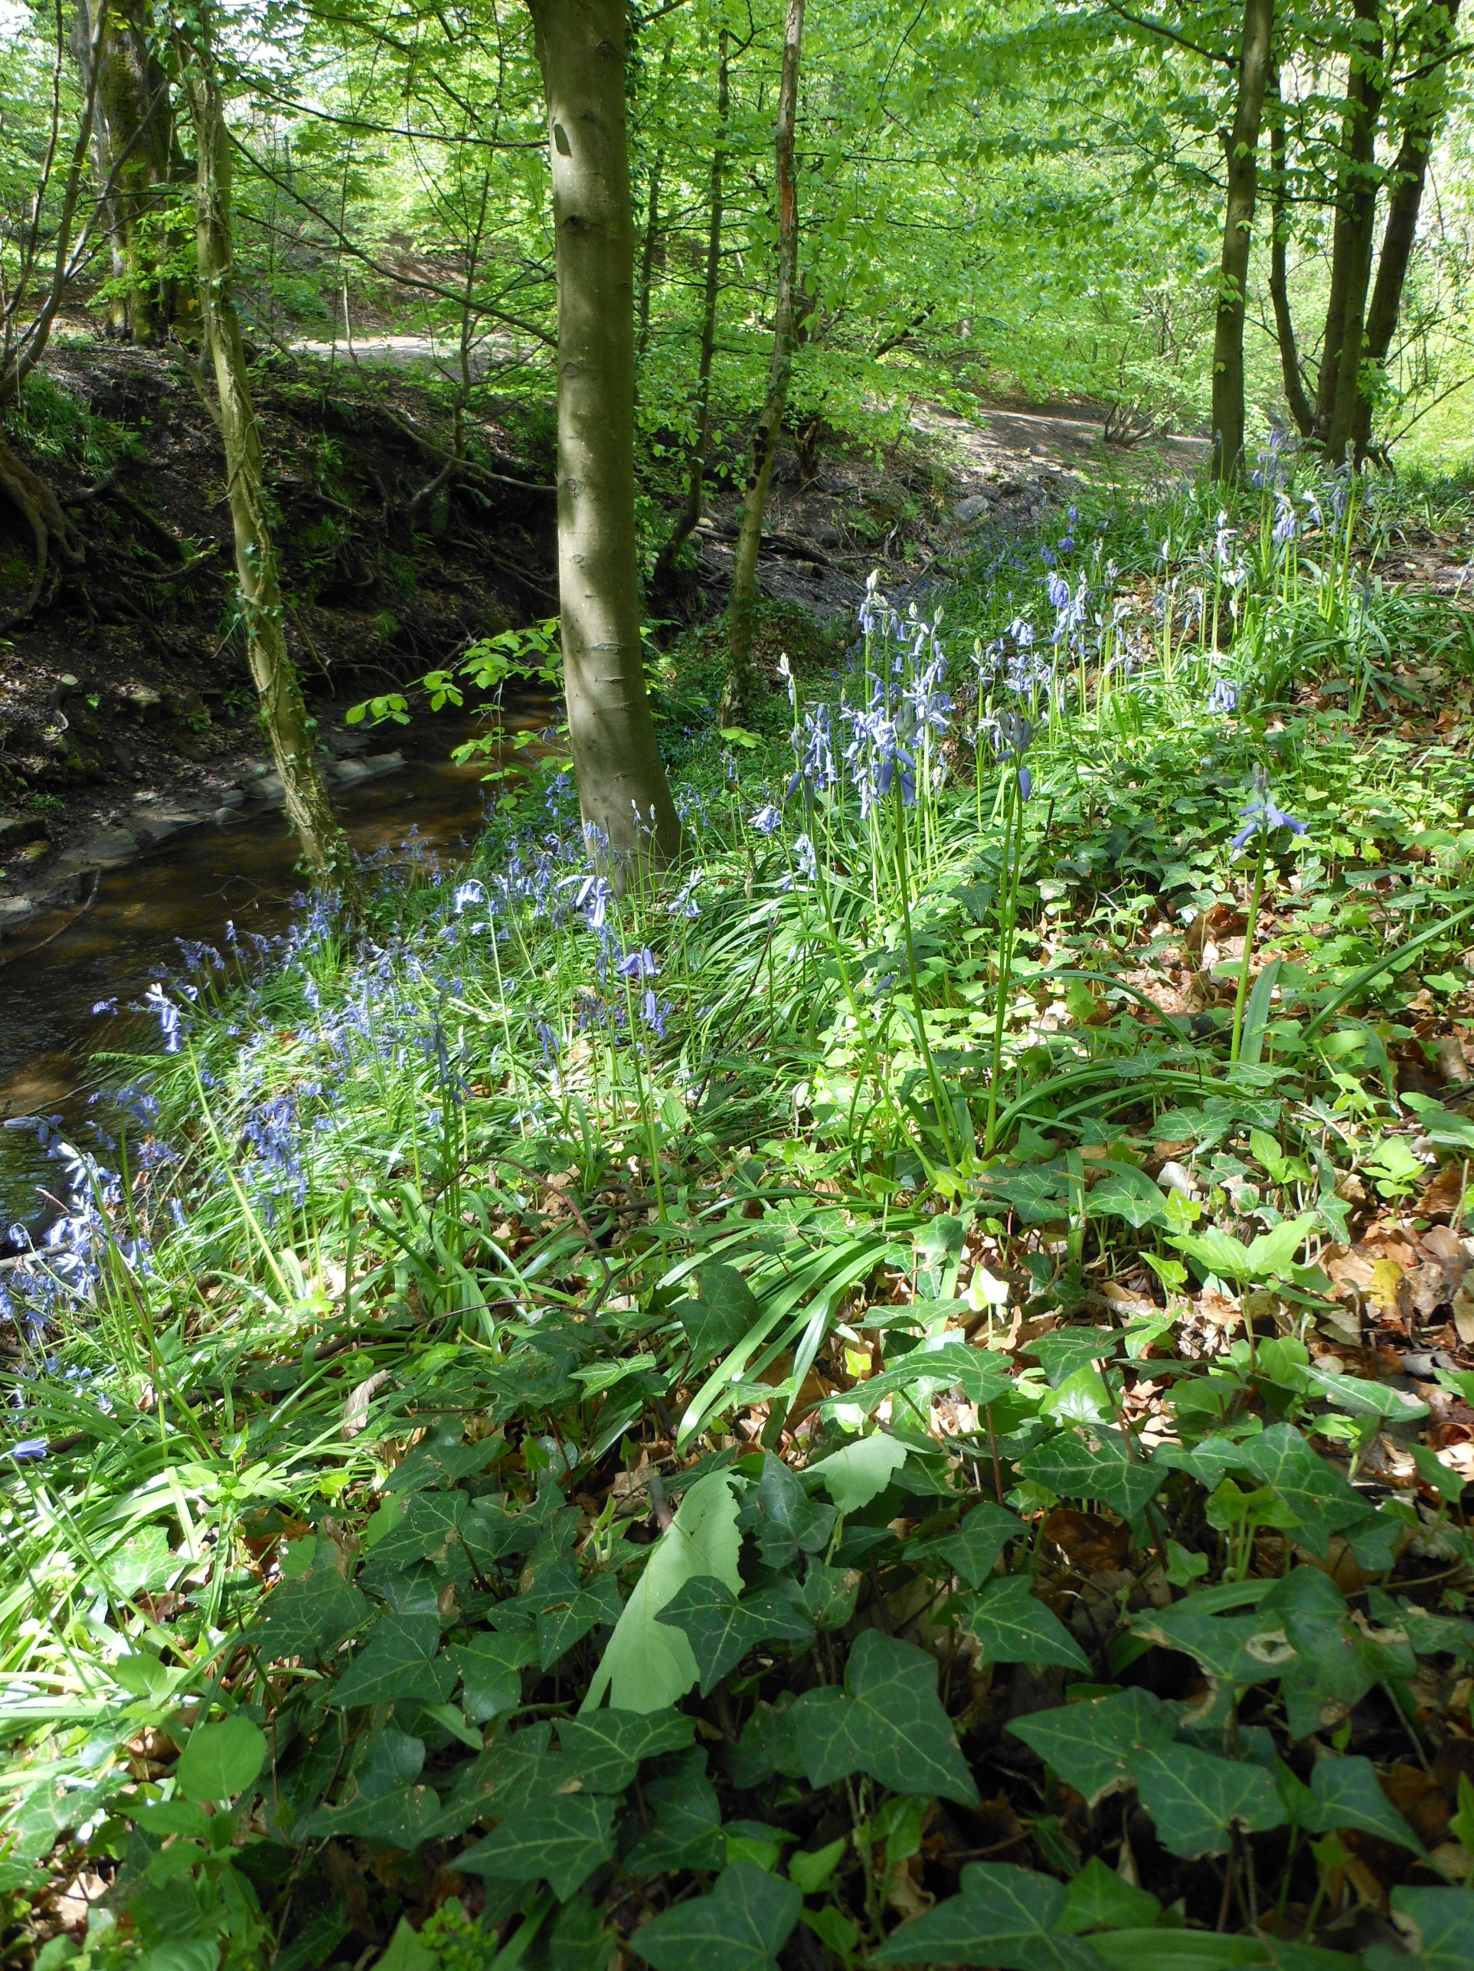
Appendices
Yarrow Valley Country Park
……………………………………………………………………………………………………………………………………………………………………

Appendix 1 – List of Respondents to the Survey by Type

Appendix 2 – List of Consultation Events and Venues

Appendix 3 – List of Sites Responses Received Against Specific Sites in Questions 64, 65 and 67.

Appendix 4 – List of Consultation Deposit Points

Appendix 5 – Detailed Response Analysis by Question

Citizen space is an online platform used by many Local Authorities and Government bodies. It is an online questionnaire which can be used to asked a series of questions and respondents can choose which questions they wish to respond to: https://centrallocalplan.citizenspace.com/

